CURRICULUM VITAE
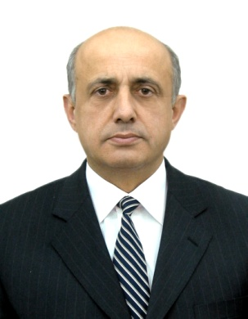

TAMAZ TURMANIDZE
Date of Birth: December 16, 1957, Batumi, Georgia
Nationality: Georgian
Marital Status: Married, two daughters
E-mail: tturmanidze@gmail.com
Tel: (995 422) 27 03 89, Mob: (+995 77) 57 12 77

EDUCATION:
1979-1986 : Lawyer, competent in French - Higher School by the name of F. E. Dzerzhinsky, Moscow

2003-2006 : Navigator, bachelor’s degree in sea navigation- Batumi Maritime Academy

PROFESSIONAL TRAINING:

2003 – European Center of Advanced Technologies (UECAT SA) – “Auditing of Quality
Management Systems to ISO 9000:2000 series of Standards, Auditor/Lead Auditor
Course”
2006 – “Russian Maritime Register of Shipping”, Training Course for the ISM Code Auditors

2006 -“Russian Maritime Register of Shipping”, Training Course for Maritime Security Auditors

2008 - Community Colleges for International Development, Inc., Teacher’s training Program in
Modern Teaching Methodologies
2009 - CESO International Services
Train the Trainer Course in Modern Instructional Services

2009 - CESO International Services
Train the Trainer Course in Shipboard Pollution, Prevention and Ecology

2010 – Admiral Makarov State Maritime Academe, Russian Maritime Register of Shipping,
program “Inspector of Recognized Organization (RS) on the Maritime Labour Convention,
2006”
2011 - PUM Netherlands Senior Experts,
Teacher’s Training Program Based on the IMO Model Course 6.09 -Training Course for
Instructors
Model Course 3-19 Ship Security Officer; Model Course 3-20 Company Security Officer;
Model Course 3-21 Port Facility Security Officer; STCW 78/2010
2012 – BUREAU VERITAS
ISO 22000:2005 – Food Safety Management Systems Lead Auditor Training Course
FSMS Lead Auditor
2014 - Global G.A.P
Global G.A.P Private F&V Workshop

CURRENT POSITION:
Ajara Chamber of Commerce & Industry – Deputy Chairman
Ajara Logistics, Transport and Shippers Association – Chairman
“RR-Westgeorgia” Ltd – Director
SAI GLOBAL – Quality Management System Auditor

ROFESSIONAL EXPERIENCE:

01.03.2005 – present - “RR-Westgeorgia” Ltd – Director

01.04.2002 – 30.11.2011- RS in Georgia - leading expert of QMS
ISM Code Lead Auditor
Maritime Security Auditor
01.05.2001 -28.03.2002 - Batumi State Maritime Academy; head of quality service
01.11.1999 - 30.04.2001- Crewing company “Ialkani-2S”; quality manager, vice-president –
quality manager.

LANGUAGES
• Georgian – native, Russian – fluent, French – fluent,
INTERESTS
• Sport, travel,

